User Manual for Resize the certificate
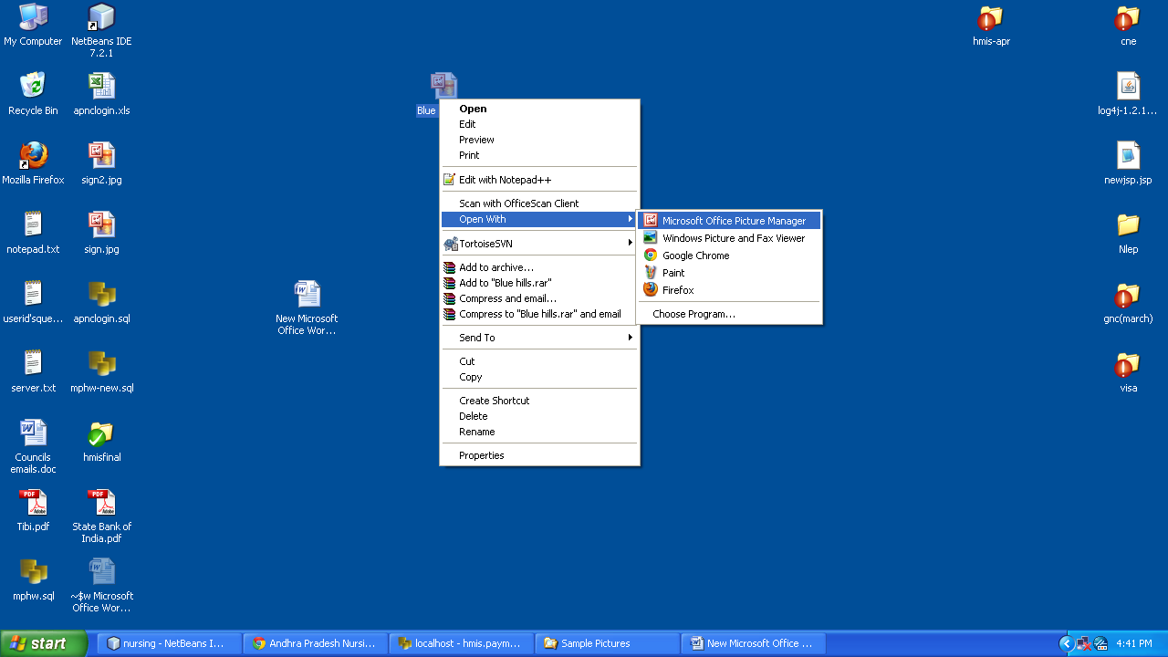
Right Click on Image & select OPEN WITH then select Microsoft Office Picture Manager then open it as below
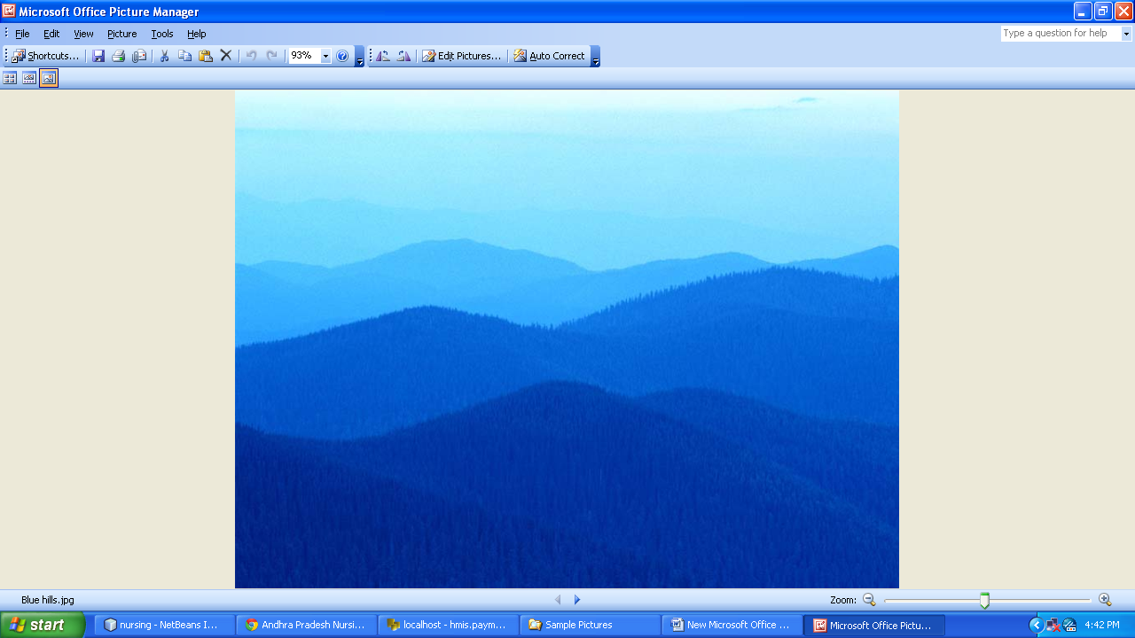

Click on Edit Pictures then open the Dialogue box at right side as below, then select Resize
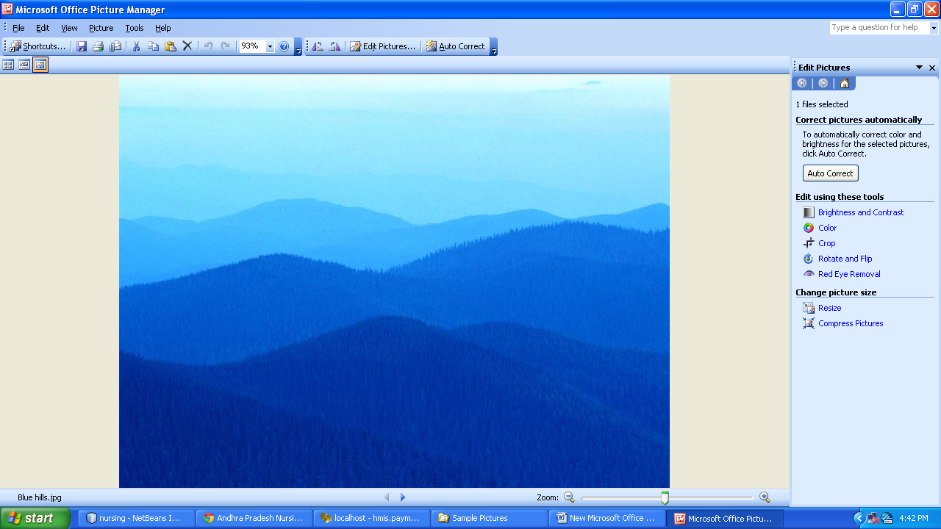

SELECT Custom width x height(300x400) then click OK
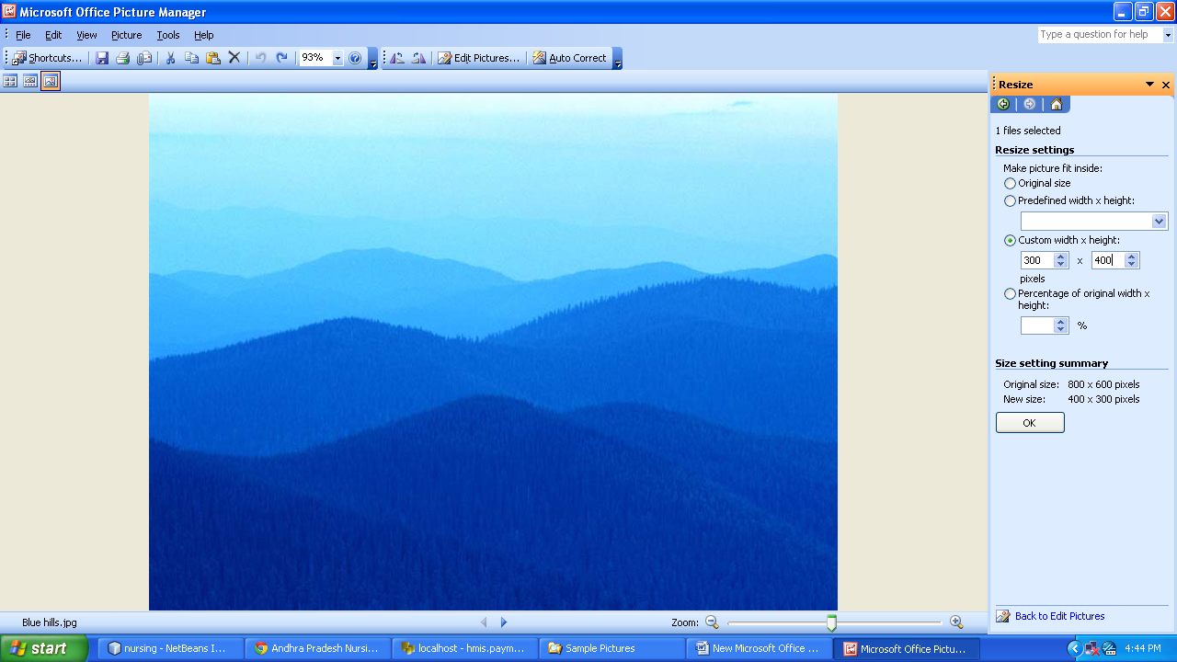
Then save the Image, it saves the image in less than 100 KB
